

SAAD USMAN

BCSP243016



May 26, 2025

WIRESHARK TASK:

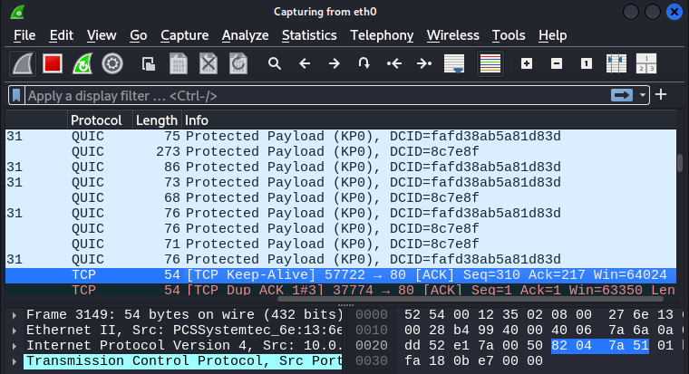

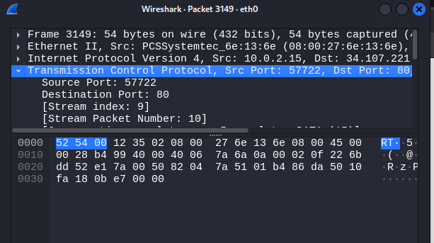

**TASK 2:**

Putting header info :

First we open test app on firefox on kali.

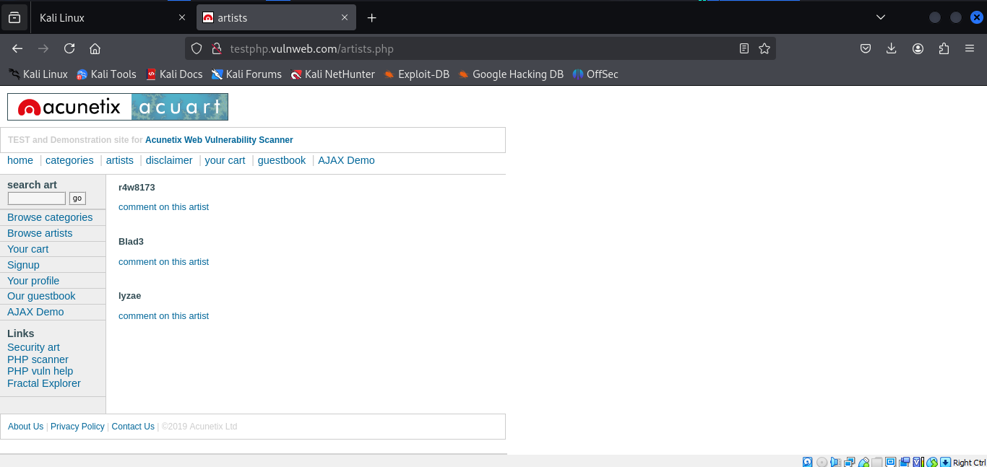

**Then by going on export objects>>HTTP**

**Then below these packests are shown.**

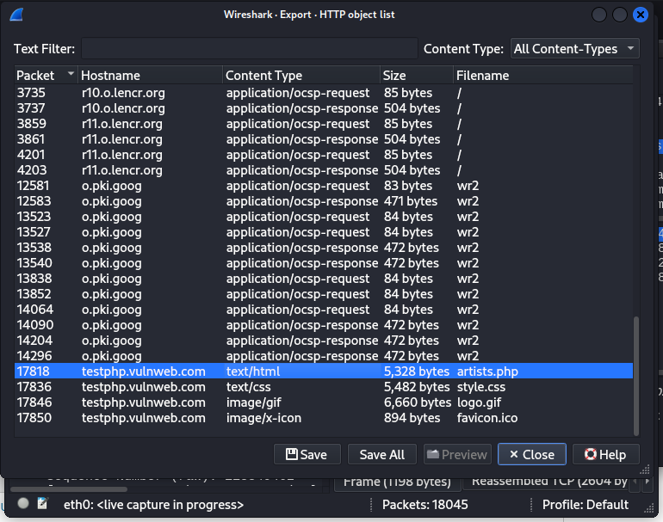

**TASK 3:**

**BY SAVING THE ABOVE FILE IN DESKTOP . THEN WE SEE A HTML FILE BELOW.**

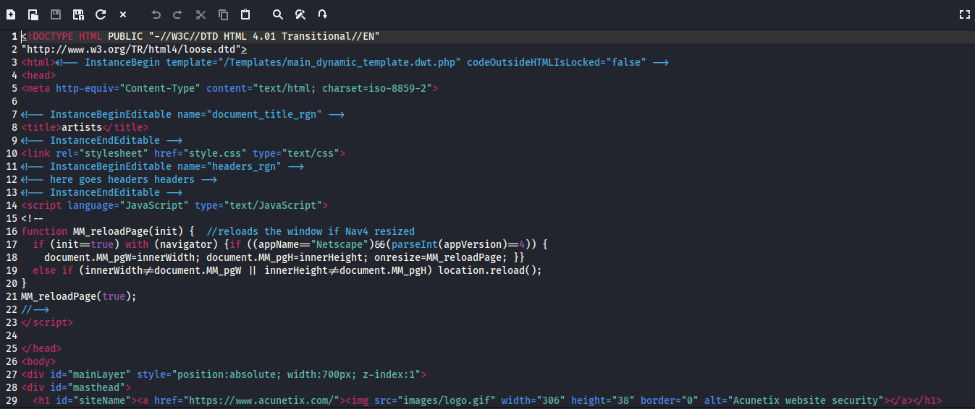

**TASK 4:**

**(TIMEZONE)**

IF WE WANT TO CHECK THE TIMEZONE , THEN WE GO TO VIEW>>TIME DISPLAY FORMAT>>THEN WE GO TO TIME AND DATE.

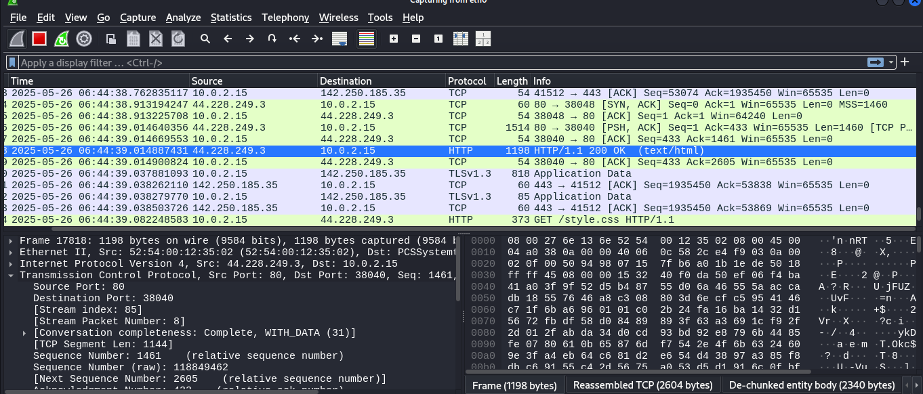

**TASK 5:**

**COLOURIZE FILTERS.**

FIRST WE GO TO ANALYZE>>EXPERT INFO THEN THIS IMAGE SHOW . IS MAY COLORS IS LIYA SHOW HUA HAIN Q KAY IS MAY KUCH PACKETS” WARNING” KAY HAIN KUCH PACKETS “NOTES” KAY HAIN , OR KUCH PACKETS “CHAT “KAY HAIN

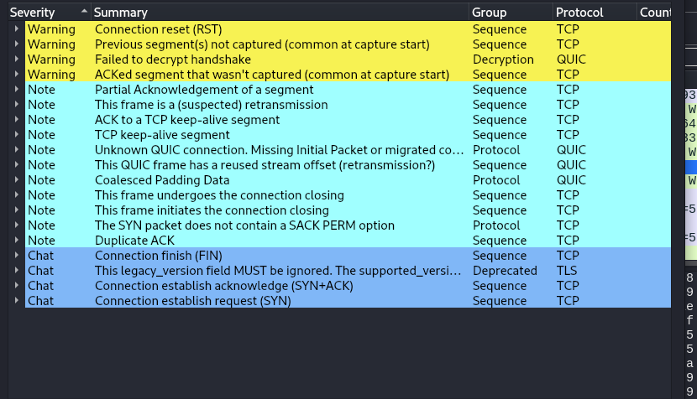

**TASK 6:**

**ABH HUM NAY FIREFOX PAY JA KAY LO0GIN KARNA HAI .**

**OR PHIR WAPIS WIRESHARK PAY ANA HAI .**

**EDIT>>FIND PACKET>>THEN SELECT STRING >> THEN SELECT PACKET BYTES.**

**THEN ENTER STRING EX”SAAD USMAN’ THEN I GOT A PASSWORD.**

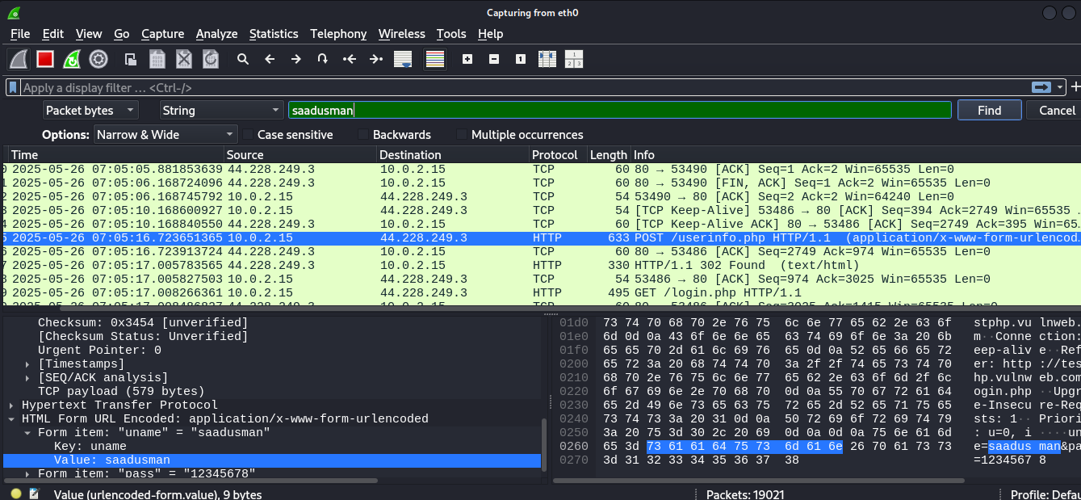

**TASK 7:**

**CONVERSATION FILTER**

**IS MAY ANALYZE>>CONVERSATION FILTER>> CHECK EHICH XATEGORY IS ENABLED . THEN WE GET THEREV ADDRTEWSS.**

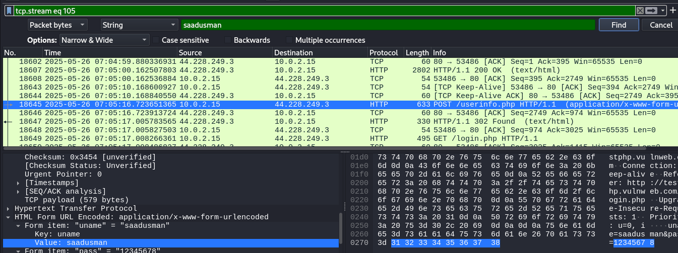

**OR ISI MAY HUM YEH BHI DEKH SAKTAY HAIN KAY KONSAY PACKETS AH RAHAY HAIN OR KONSAY PACKETS JAA RAHAY HAIN.**

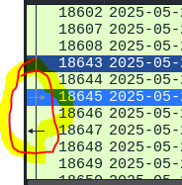

**TASK 8:**

**COLOURISE COVERSATION:**

**SABH SAY PEHLY** "View --> Colourise Conversation" **YAHAN PAR JANAY KAY BAD HUMARA COLOR CHANGE HOO JAYE GA.**

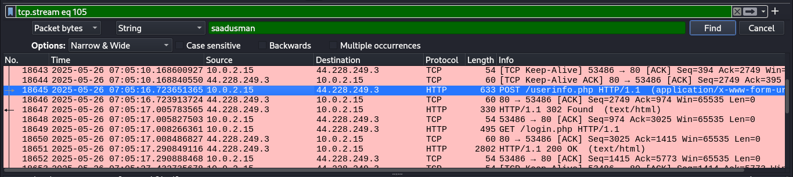

**PREPARE AS FILTER:**

**PEHLY RIGHT CLICK KAR KAY FILTER SEKECT KARAIN GAYE PHIR , PREPARE AS FILTER>> SELECTED.**

**PHIR NEXZT IMAGE SHOW HOO GHI .**

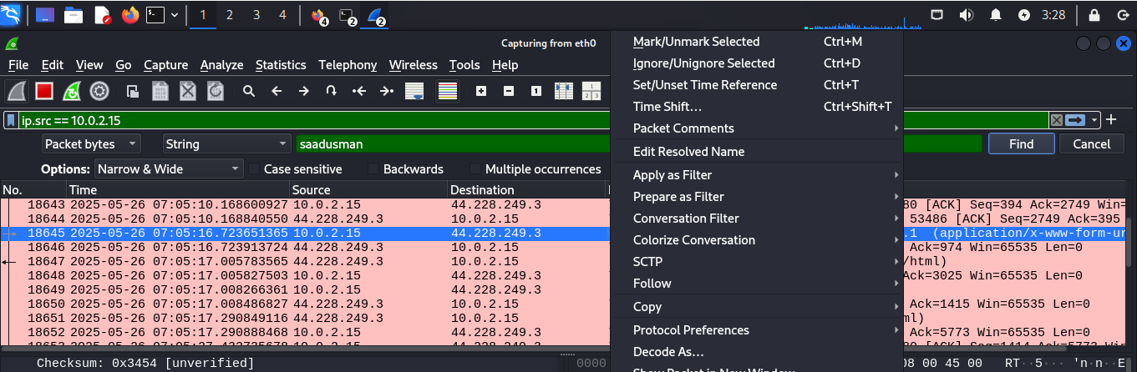

**TASK 9:**

Apply as Column:

MATLAB ABH HUMAY APNA DATA COLUMN WISE CHAHIYA.

SABH SAY PEHLY ANALYZE>> APPLY AS COLUMN .

PHIR IMAGE SHOW HOO GHI.

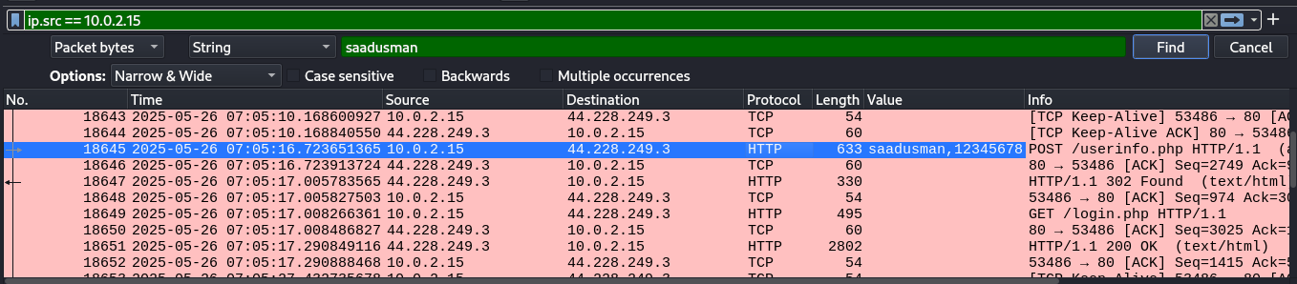

**TASK 10:**

**Follow Stream**

**SABH SAY PEHLY** "Analyse --> Follow🡪 TCP/UDP/HTTP Stream" (TCP/HTTP ) MAY SE KOI SELECT KARAIN GAYE.

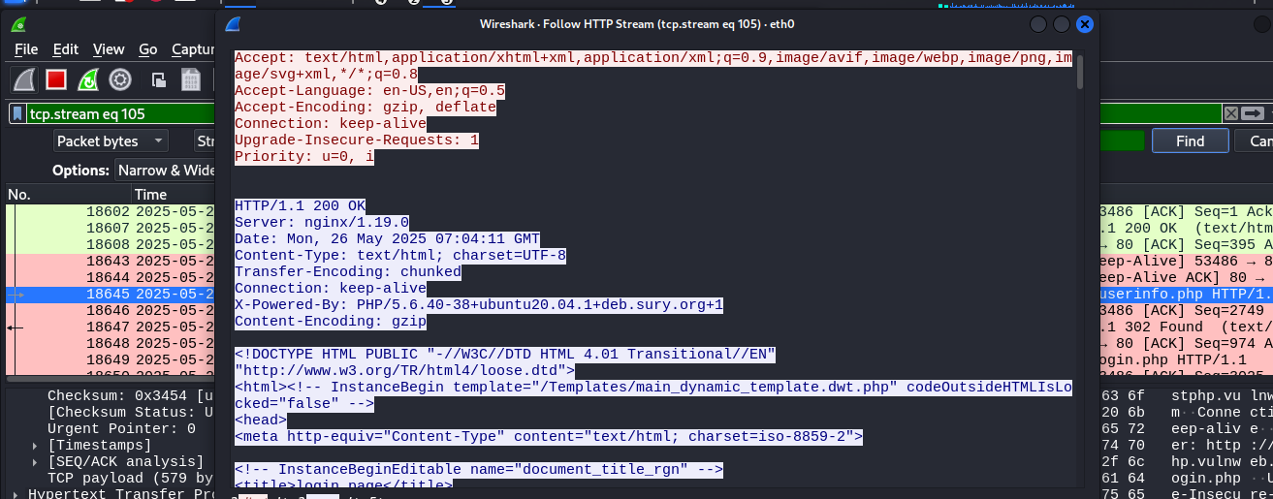

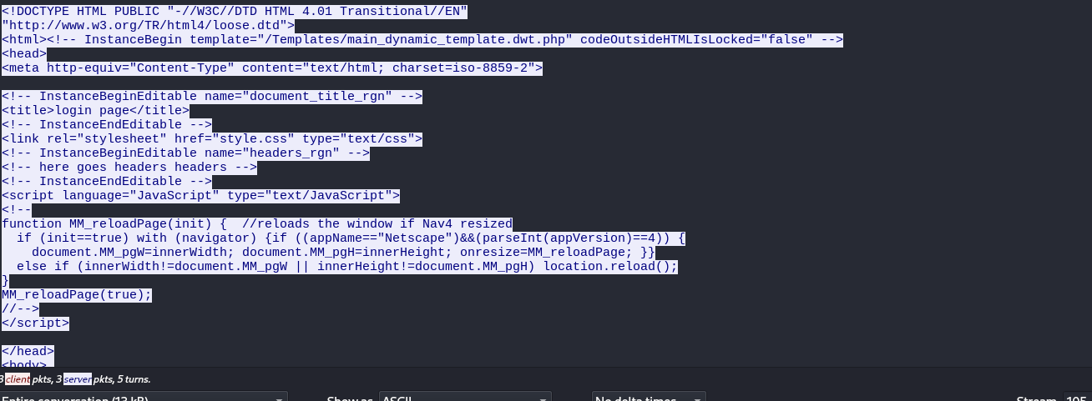

**TCP STREAM SS:**

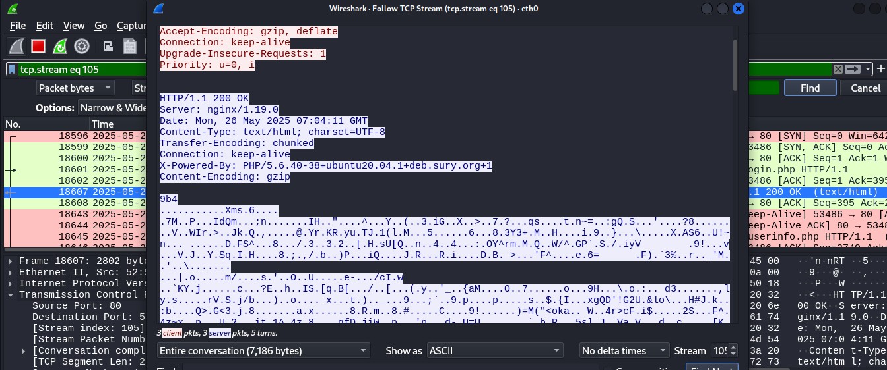

**TASK 11:**

**Statistics:**

**Resolved Addresses:**

"Statistics --> Resolved Addresses"

MAY HOST PAR IS LIYA NAHI GYA Q KAY MAY PROXY SAY CONNECT HOON MENAY IS LIYA “ETHERNET” CHOOSE KIYA HAI.

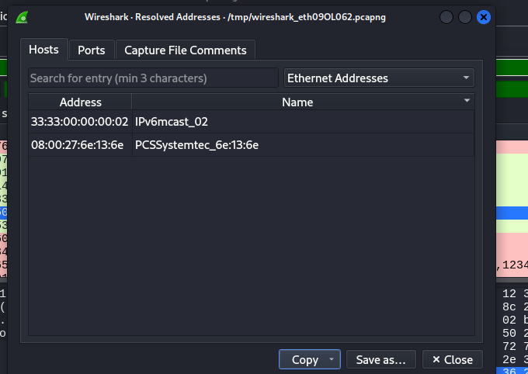

**TASK 12:**

**Protocol Hierarchy:**

"Statistics --> Protocol Hierarchy"

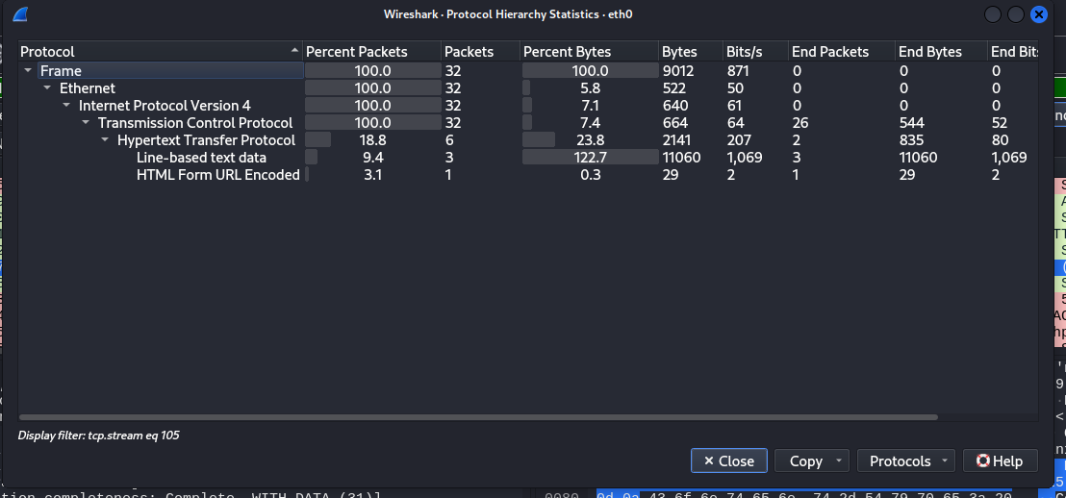

**TASK 13:**

**Conversations:**

Conversation represents traffic between two specific endpoints. This option provides the list of the conversations in five base formats; ethernet, IPv4, IPv6, TCP and UDP. Thus analysts can identify all conversations and contact endpoints for the event of interest.

**"Statistic --> Conversations"**

**TCP.1**

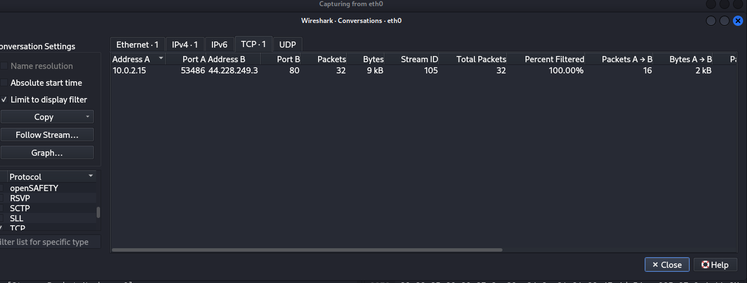

**IP V4.1:**

